**SW Engineering CSC648/848 Fall 2020**

**Code: “Coronafirus”**

**Section 02**

**Team 01 Members:**

Thomas Abadines (Team Lead) (tabadines@mail.sfsu.edu)

Vito Gano (Project Manager) (vgano1@sfsu.edu)

Souhib Trabelsi (Github Master)

Junhao Zhai (Backend)

Amily Wu (Document Master)

Trung-Duong Pham-Vu (Front End)

**Milestone 2**

**10/06/2020**

**Revision: v.1.1**

**(Submitted: 10/06/2020, Revised: 10/13/2020)**

History:

Revision: v.1.0 - Released (10/06/2020)

**1. Functional Requirements - prioritized**

1. Covid metrics input (Deaths): Directors will be able to enter covid cases by county - be able to enter covid deaths
2. Covid metrics input (Recovered): Directors will be able to enter covid recovered
3. Covid metrics input (Infected): Directors will be able to enter covid infected
4. Wildfire/fire input - Directors will be able to input number of wildfires
5. Evacuation Level - Directors will be able to set levels of evacuation for county (L1, L2, L3)
6. Search - Normal users should be able to search statistics for counties
7. Register and Login - Normal users should be able to register for site
8. Notify Alerts - Administrator should be able to trigger alerts for shelter in place or evacuation
9. Receive Alerts - Users should be able to receive alerts for shelter in place or evacuation
10. Modify/Delete items and :users - Administrator should be able to delete inappropriate items or users
11. Log/Track - Site should have log to track activities/modifications made by users
12. Posting items/data - items will need to be approved by the administrator before posting it online
13. Alert + Health center location - Alerts will show nearby evacuation center and hospitals
14. Notify when Evacuation centers are Overcrowded/Full - Will allow people who run evacuation centers and hospitals to send notifications when centers are crowded. This will allow people who are at higher risk for corona to avoid places that have a high influx of people.
15. Basic search - Allows users to search by zip code or city
16. View Interactive map - Users that are doing a search can see an interactive map that displays where the latest location of the fires are, the number of cases of COVID for each county, the nearest hospitals and shelter areas for wildfire evacuation.
17. View statistics - Users that are doing a search can also see a more finely detailed description and layout of the numbers pertaining to the issues related to the number of deaths in COVID, Wildfires, Numbers of areas/homes destroyed and such…
18. Bug/Issue Reporting - Users who come across bugs or other issues with the site will be able to fill out a questionnaire in order to inform the administrators about the issue.
19. Filtering data - Administrators will be able to filter through the data on the site through use of an administration panel
20. Linking multiple accounts - Relatives of users will be able to request to be added to a user’s account and push notifications to that account. Relatives will be able to send personal notifications to that account only. Requests will be screened and users will be asked before accounts are shared.
21. Notification customization - Directors will be able to send forms to administrators with all information they want to be sent out on the alert, the forms will directly show administrators what the directors want to be sent out on the alerts

Tasks and Priorities :

|  |  |
| --- | --- |
| Functions | Priority |
| **Normal users** |  |
| Search | **1** |
| View Interactive map | **1** |
| View Statistics | **1** |
| Interactive search | **2** |
| Filtering by counties and/or zip code | **2** |
| Register and Login | **3** |
| **Directors** |  |
| Register and Login | **1** |
| Covid metrics input (Infected) | **2** |
| Wildfire/fire input | **2** |
| Evacuation Level (L1, L2, L3) | **2** |
| Covid metrics input (Deaths) | **2** |
| Covid metrics input (Recovered) | **2** |
| Notification customization | **3** |
| **Administrator** |  |
| Register and Login | **1** |
| Posting items/data | **2** |
| Filtering data | **2** |
| Notify Alerts | **2** |
| Modify/Delete items and users | **2** |
| Log/Track | **3** |
| **Registered Users** |  |
| Receive Alerts | **1** |
| Alert + Health center location | **2** |
| Bug/Issue Reporting | **3** |
| Linking multiple accounts | **3** |

**2. UI Mockups and Storyboards (high level only) (Thomas & Trung)**

Home page:

Starting page for all non registered users.

Register link: Will allow users to create accounts and request for special privileges to be allowed to account.

Sign in link: After the account is created, it will direct users to the appropriate user starting page.

Map: Shows all current fire and corona hotspots

Filter option: Will allow users to fill in field in order to narrow and filter out results that don’t matter to them

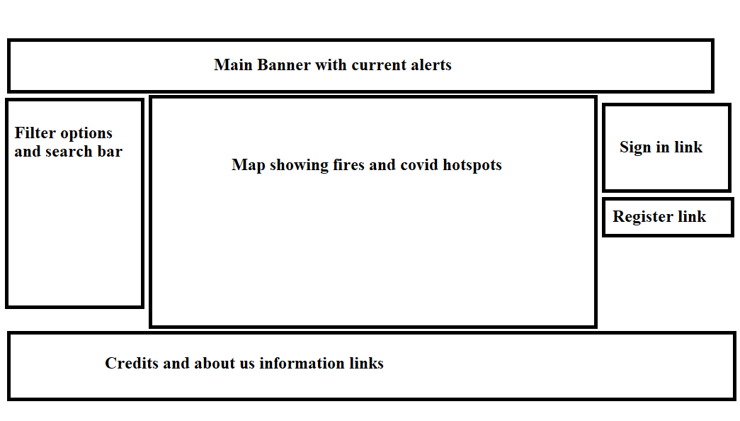

The register page will allow users to input personal information such as name and/or other proof if they are trying to make a director or other special account.

Personal information field: Will allow users to customize their account to get alerts that are relevant to them/their area.

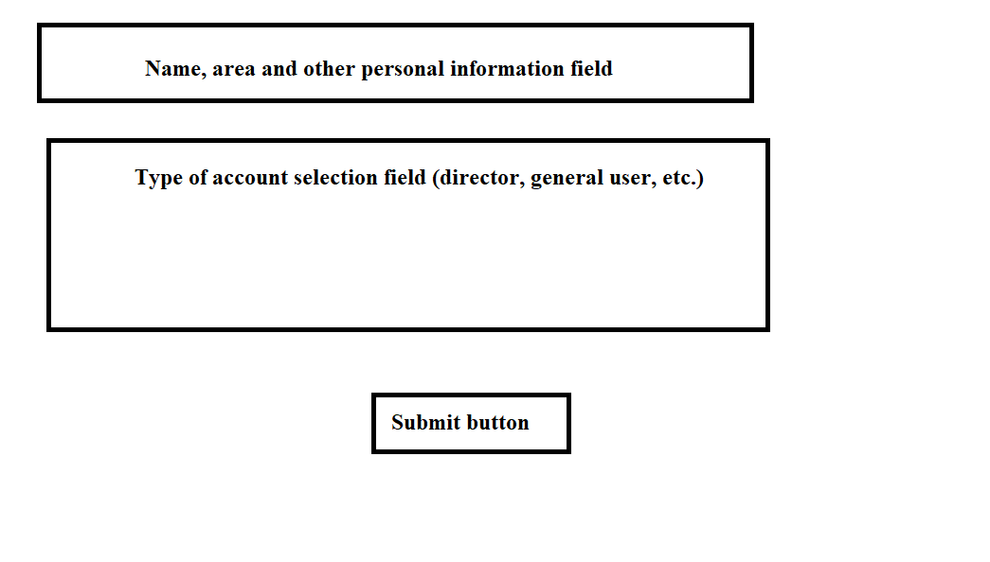

County director page

Current statistics: Will show currently inputted data for covid and or fires

Link for data changes: Will bring director to statistic/data page for covid cases

Link for shelter in place requests: Will bring director to alert submitting page for sheltering in place for their area.

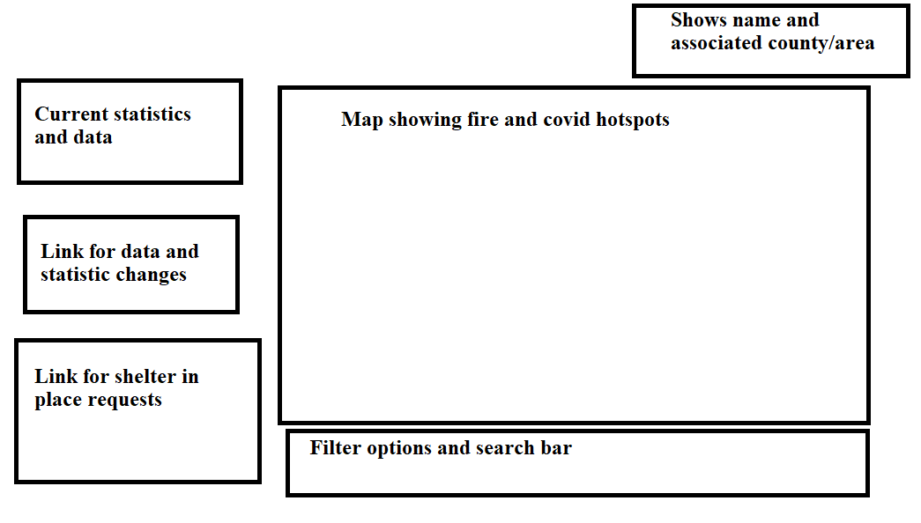

County director data entry and editing page:

Current information: Will show current inputted data and statistics for covid in the county.

Changing/update field: Will allow directors to submit changes for approval by administrators.

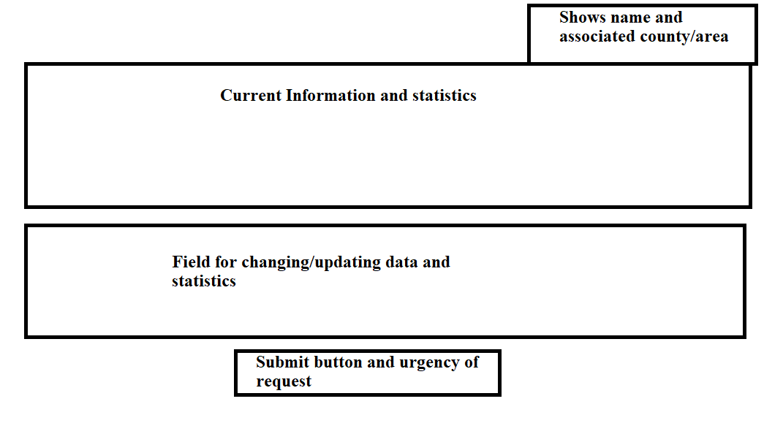

County Director Alert submission page:

Field for information and instructions: Will allow directors to fill out any information directly pertaining to sheltering in place for the county.

Additional information: Field for any other miscellaneous info direct wishes to add.

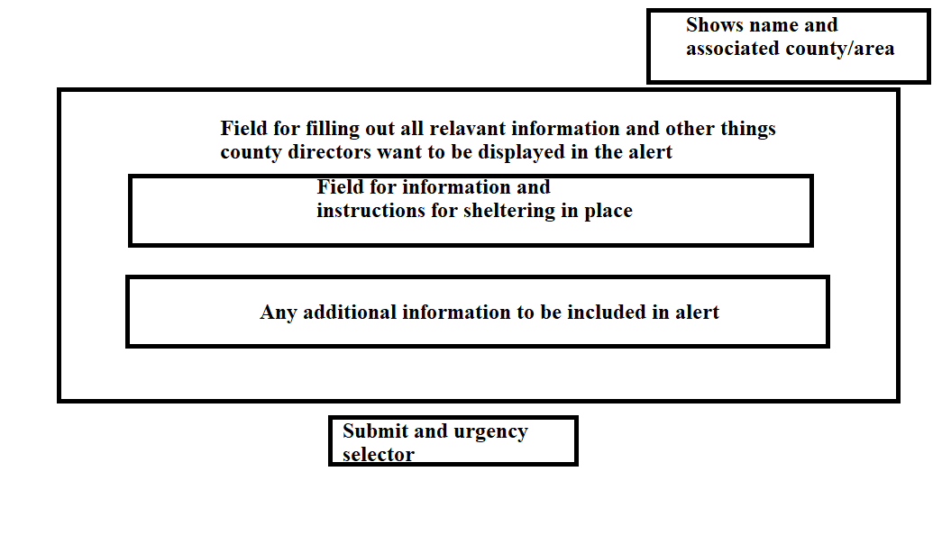

Fire Director

Current statistics: Will show currently inputted data for covid and or fires.

Link for data changes: Will bring director to statistic/data page for fire cases.

Link for evacuation requests: Will bring director to alert submitting page for evacuations.

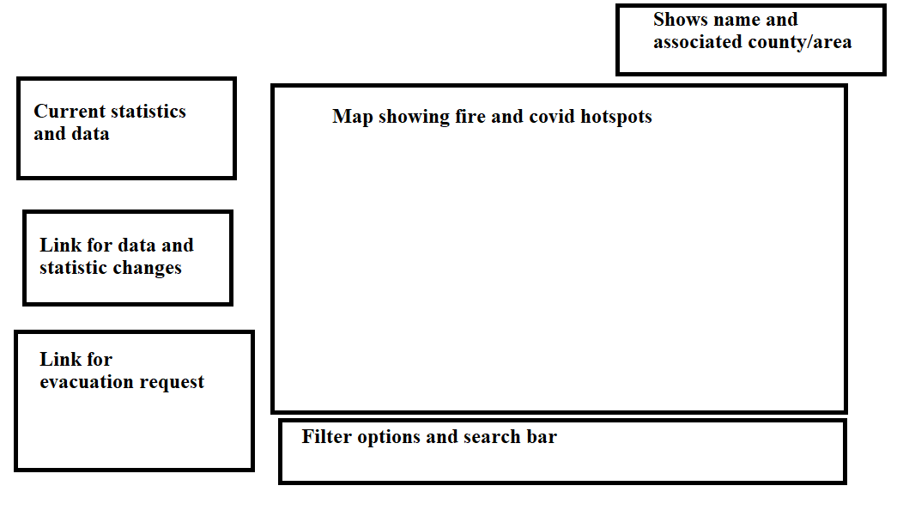

Fire director data entry and editing page:

Current information: Will show current inputted data and statistics for fires in the county.

Changing/update field: Will allow directors to submit changes for approval by administrators



The Fire Director is able to create Fire Alerts, which consist of the county, details about the evacuation, the evacuation level, and extra notes on the severity and danger.

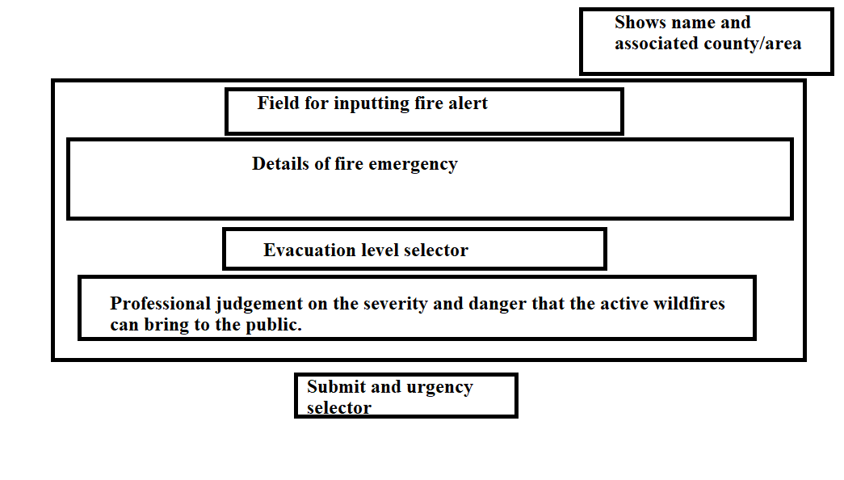

Administrators start page:

Administrator Panel: Will show any new alert requests that were submitted by directors for review.

Link to data management page: Link will go to administrators data management panel where they can sort, review, and approve data changes.

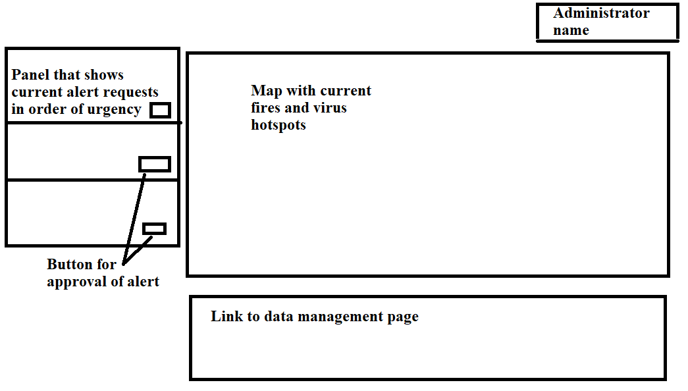

Administrator data review panel:

Data filtering panel: Will allow administrators to sort data in order to make it more viewable and easier for them to find data

Data panel: Shows all data for fires and corona cases and relevant statistics

Field for data change: Will allow administrators to see requests for changes and allow them to modify or approve data changes.

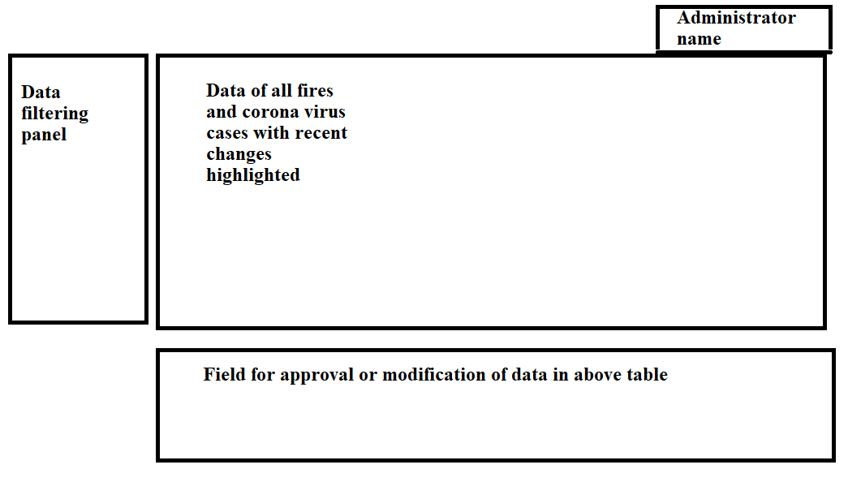

Evacuation centers and hospital directors

Map: Shows California map of wildfires and covid outbreaks

Filter options: Will work the same as general users, allowing them to sort map notices by county

Link for overcrowding alert: Will send hospital and evacuation center directors to page that allows them to write up an alert to warn of overcrowding for their center to administrators for approval.

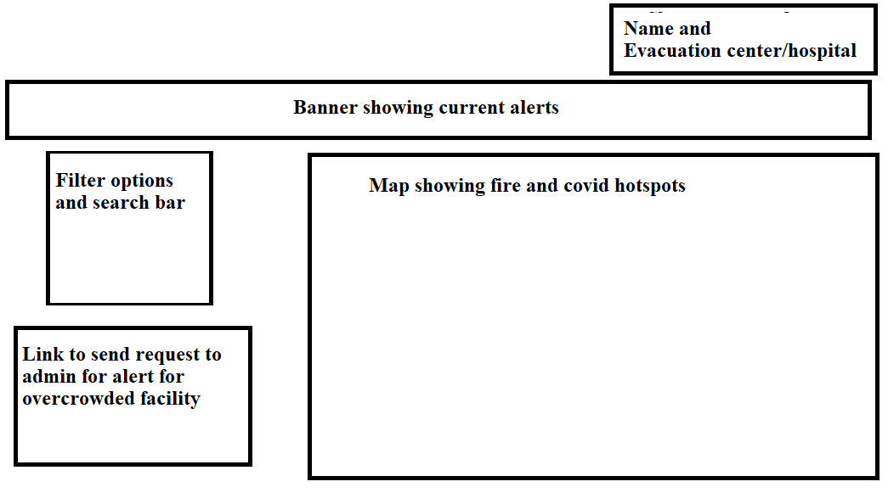

Evacuation center and hospital overcrowded alert request page

Information about capacity limit: Will allow hospital directors to submit key details about their area reaching maximum safe capacity.

Additional information: Will allow hospital directors to add any additional information that they want on the alert, such as alternative evacuation sites.

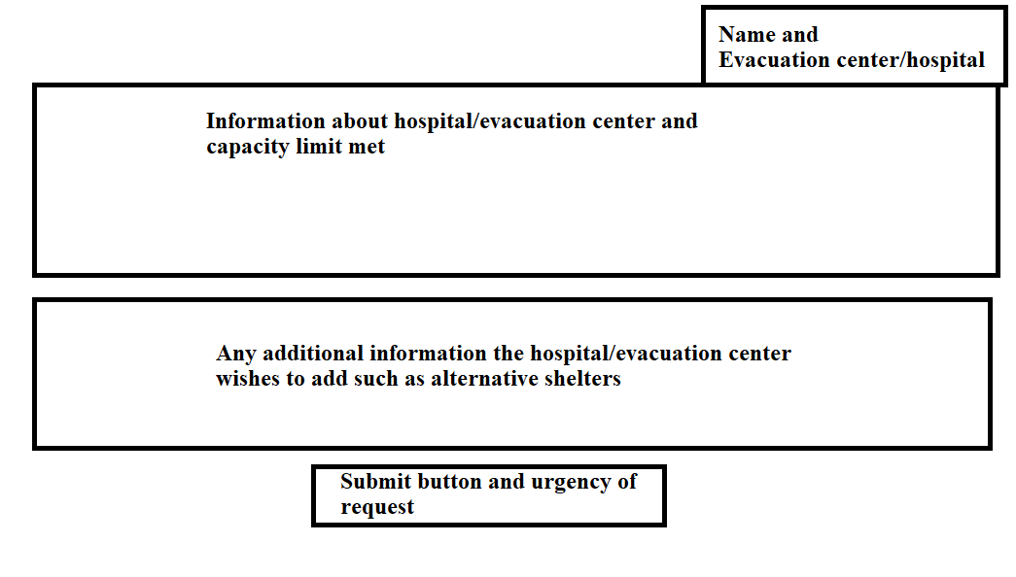

General users:

Map: Will show all fires and corona hotspots

Filter options: Will allow user to filter and search for fires and corona cases by county

Link to personal messages page: Will go to a page where users can design and send messages to themselves/their personal devices.

Link to bug report: Will go to a page that allows users to report any issues they encounter with the site.

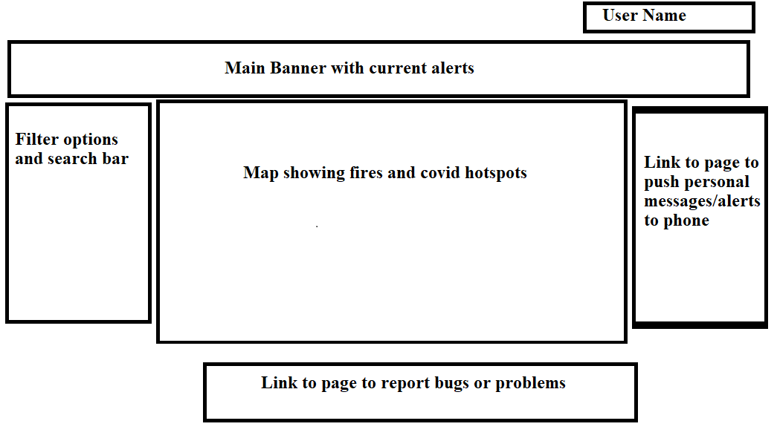

User personal message/alert page:

Field to input personal message: Will allows users to make and send personal alerts and messages to themselves to act as reminders.

User phone number field: Allows users to input the phone number that they will use to receive messages.

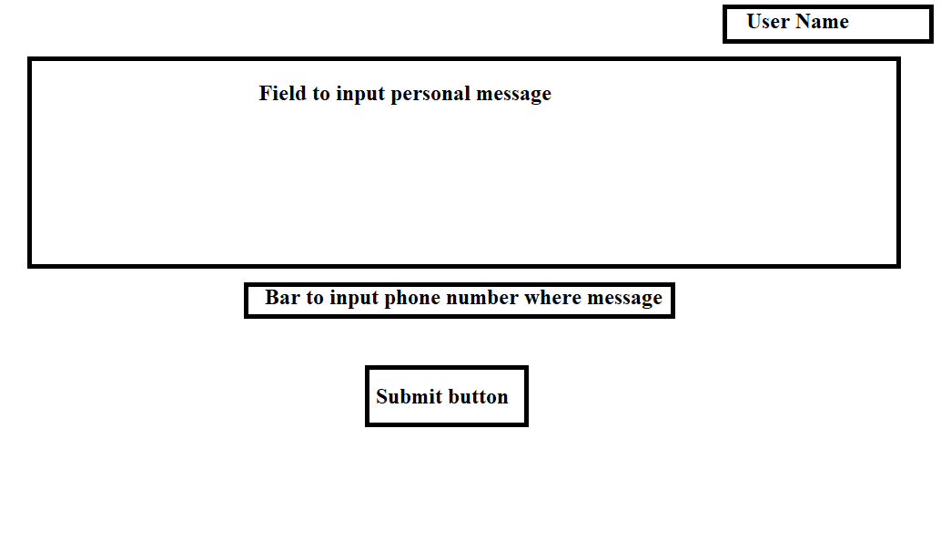

User bug report page:

Field to report bugs or issues: Will allow users to type in detail what problem or bug they encountered and any other information they wish to submit for review.

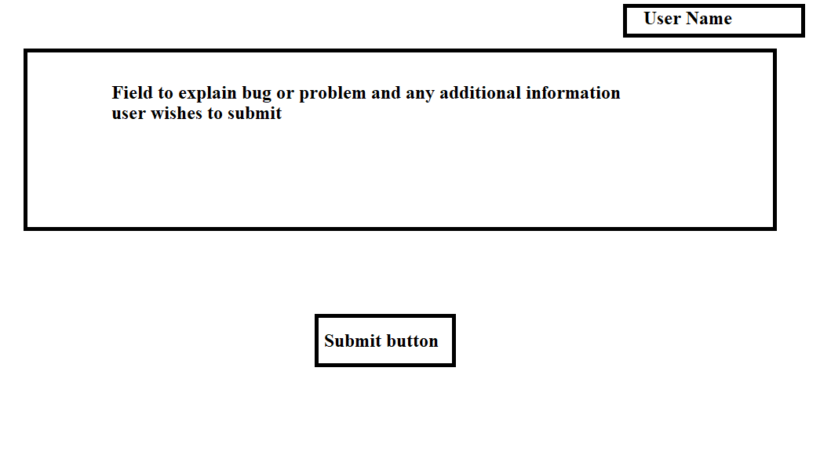

**3. High level Architecture, Database Organization**

i). DB Organization: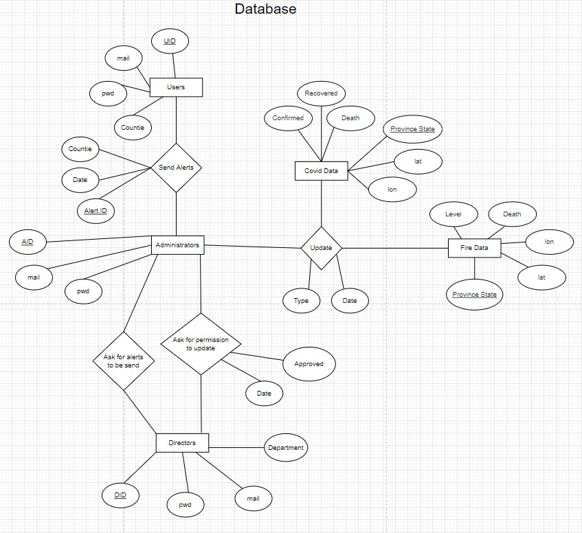

ii)

Our website will focus on functionality and user experience, so there will not be too many media-related options. We are currently not considering using video and are planning to use almost 3 or 4 pictures. We have decided to store all images in the file system. Relative to the local computer and remote server, the path of each image file (.png, .jpg, etc.) of the portable and runnable application will be saved in the local server together with the path of each file. We have not yet determined how the files will be uploaded. We will use these images as the background image of our website so they do not need to be loaded every time.

iii)

1. What will be the algorithm/SW for search?

With the help of MySQL database, we don't have to design low-level search algorithms ourselves. Instead, we will directly use the SQL language. For the search, we will use SQL query, and %like will search for the item that best matches the keyword entered by the user. The search results will be based on the best results for the product title and/or description.

The search will involve the tables CovidData and WildfireData in the database. For table entries, the database term used for searching is county/province, title and description, where county is a foreign key connected with the primary key ID in the table CovidData. For the table category, the title of the database term is only displayed to the user in text format, but is not included in the search process.

1. 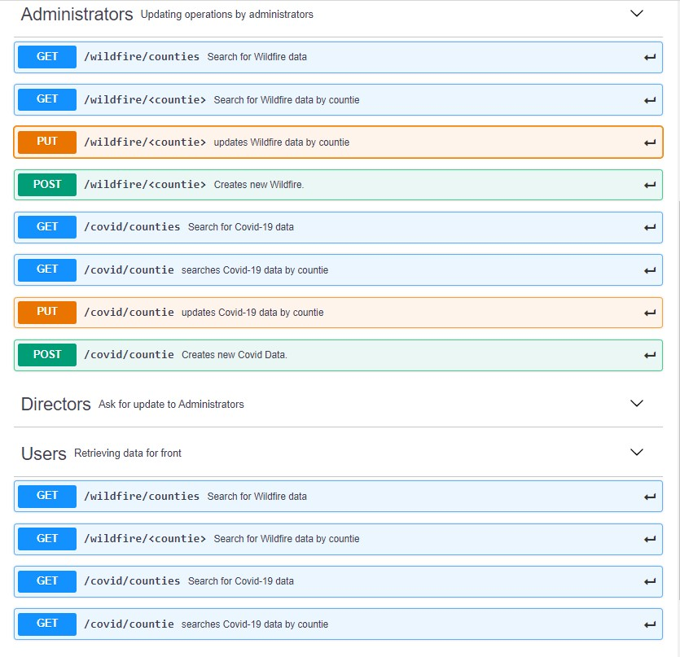Documentation of our API :

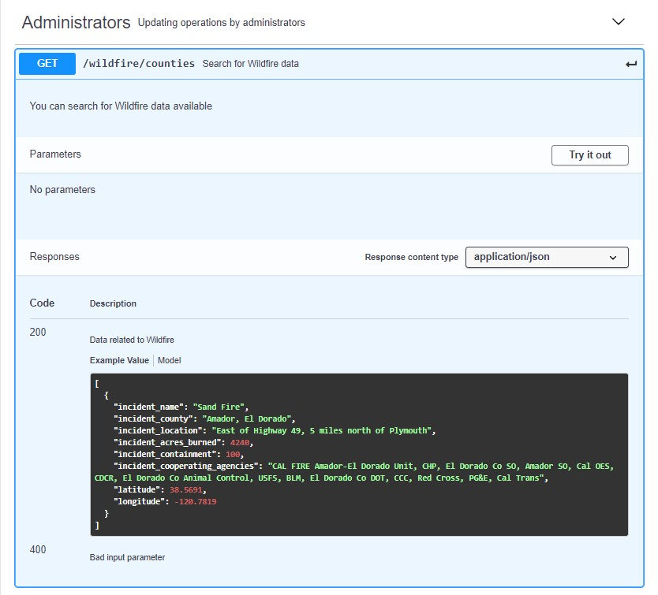

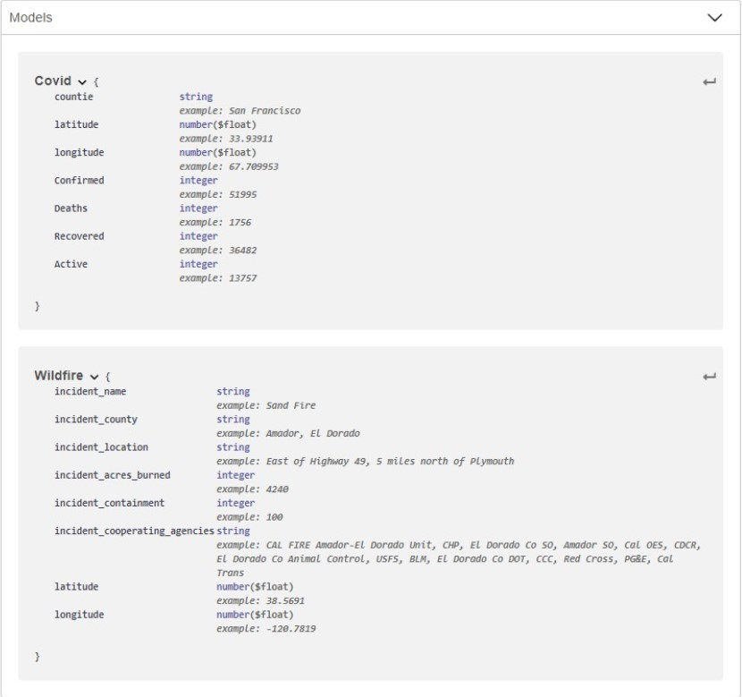

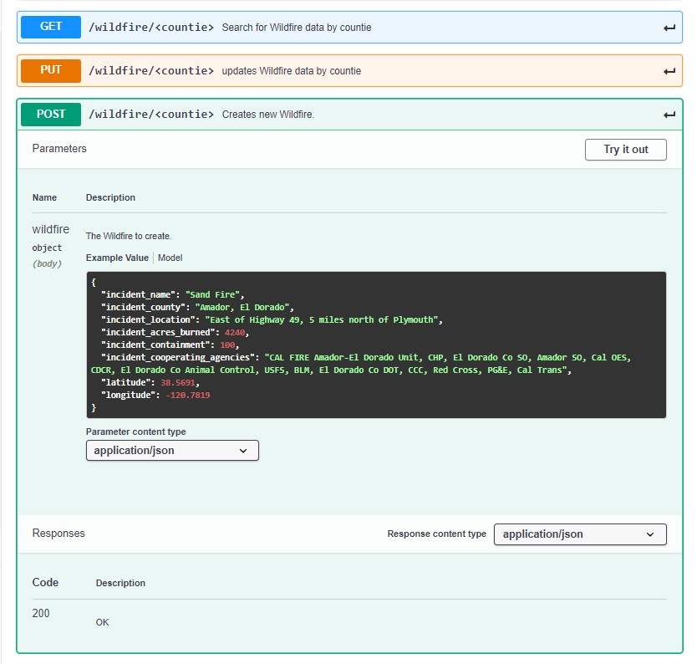

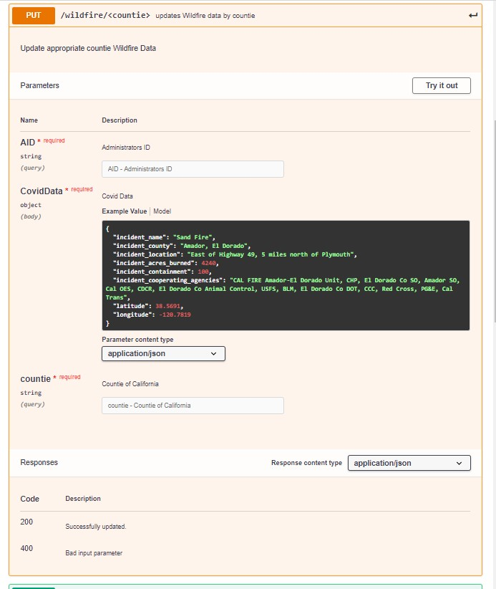

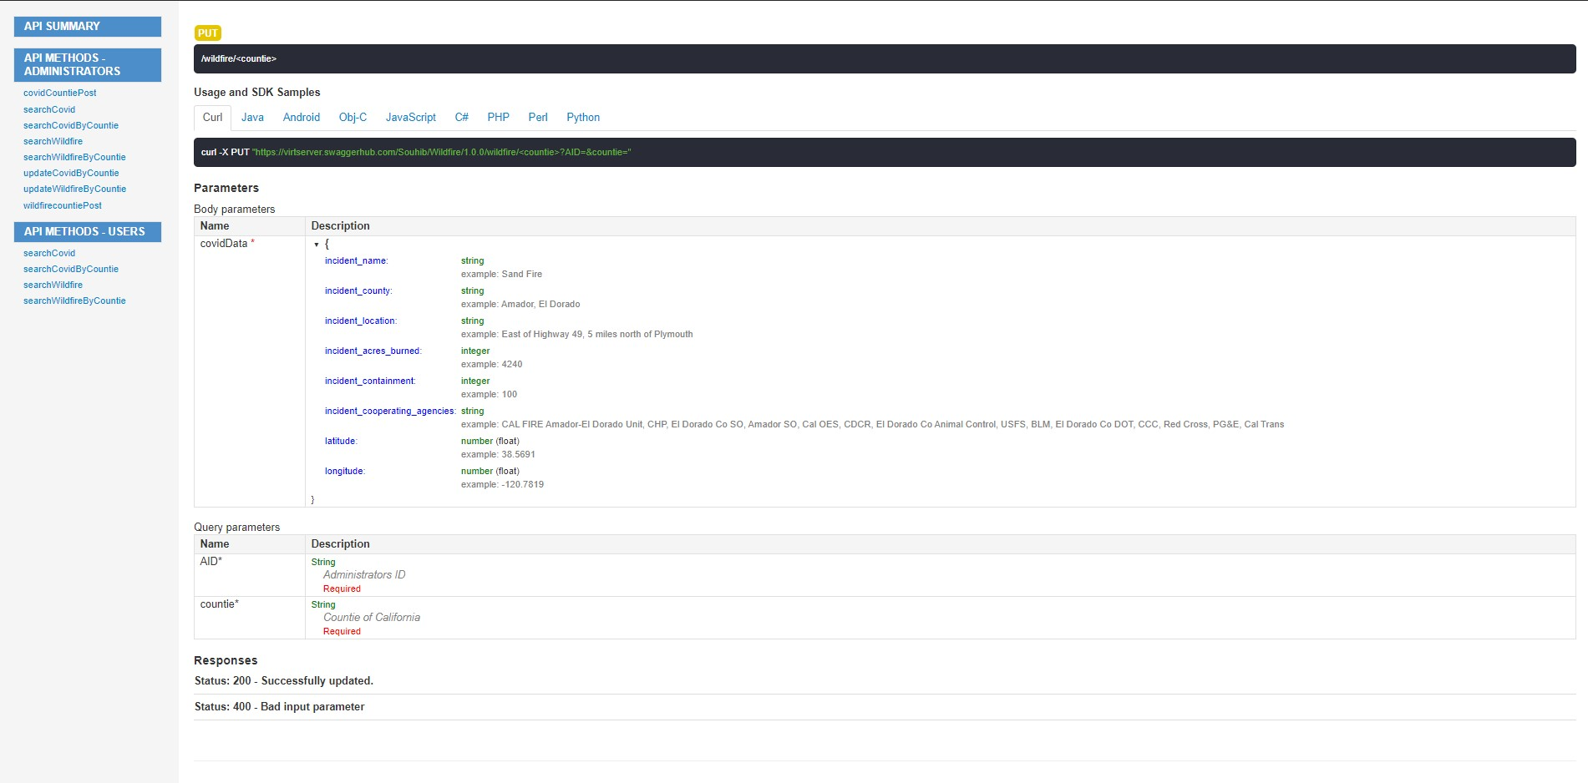

**4. High Level UML Diagrams**

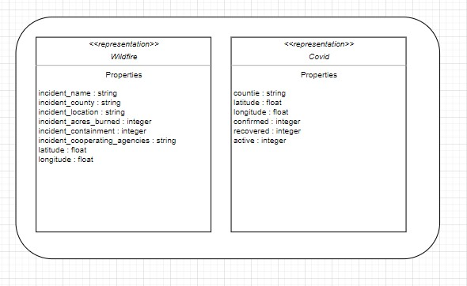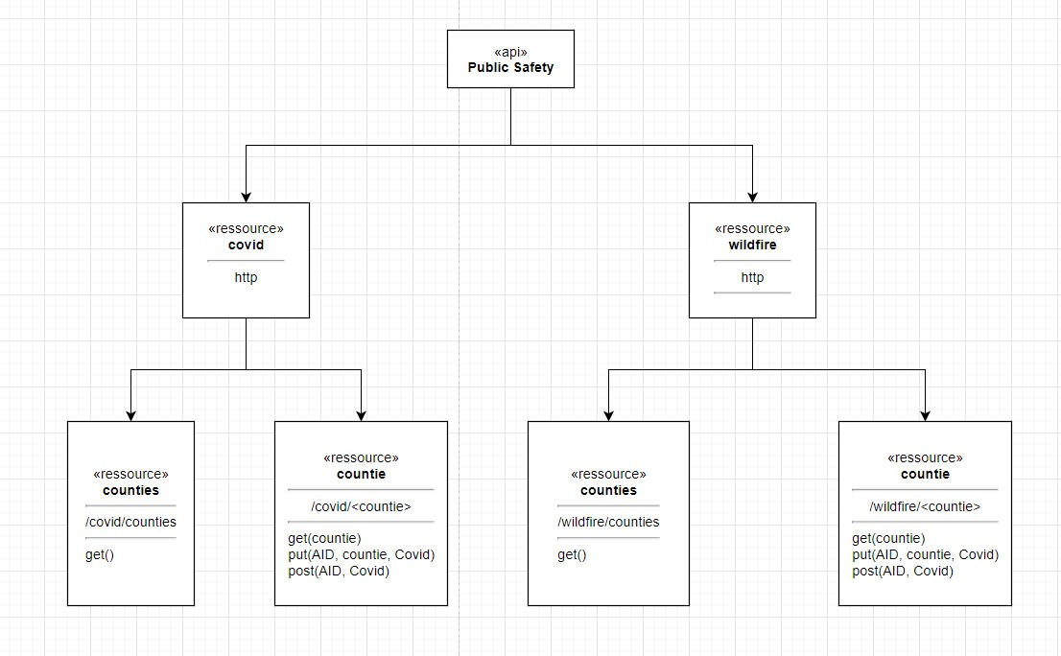

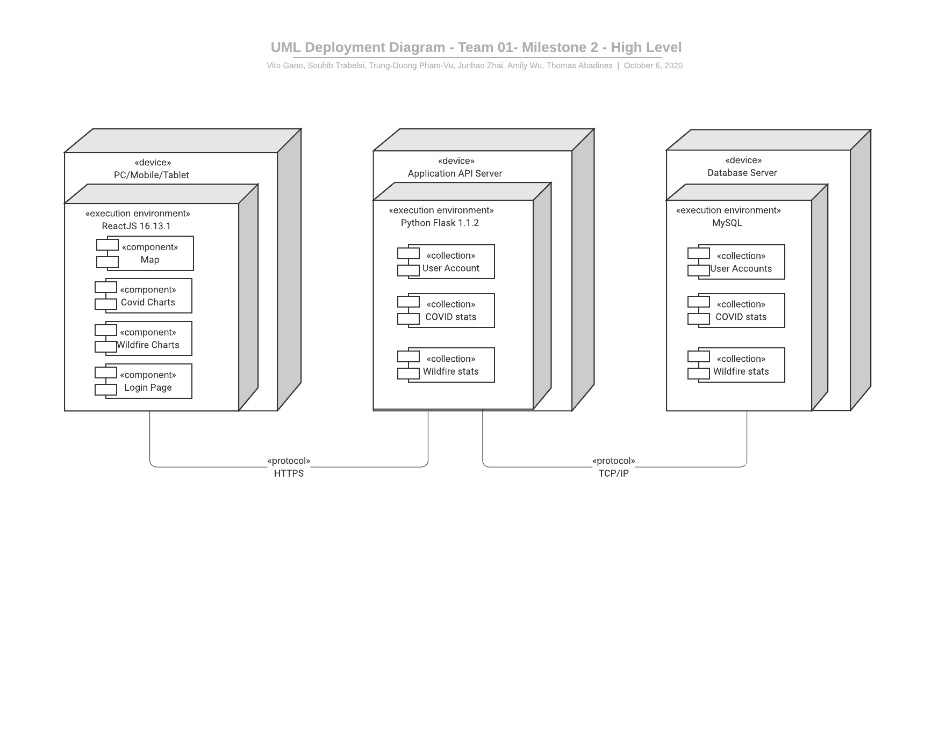

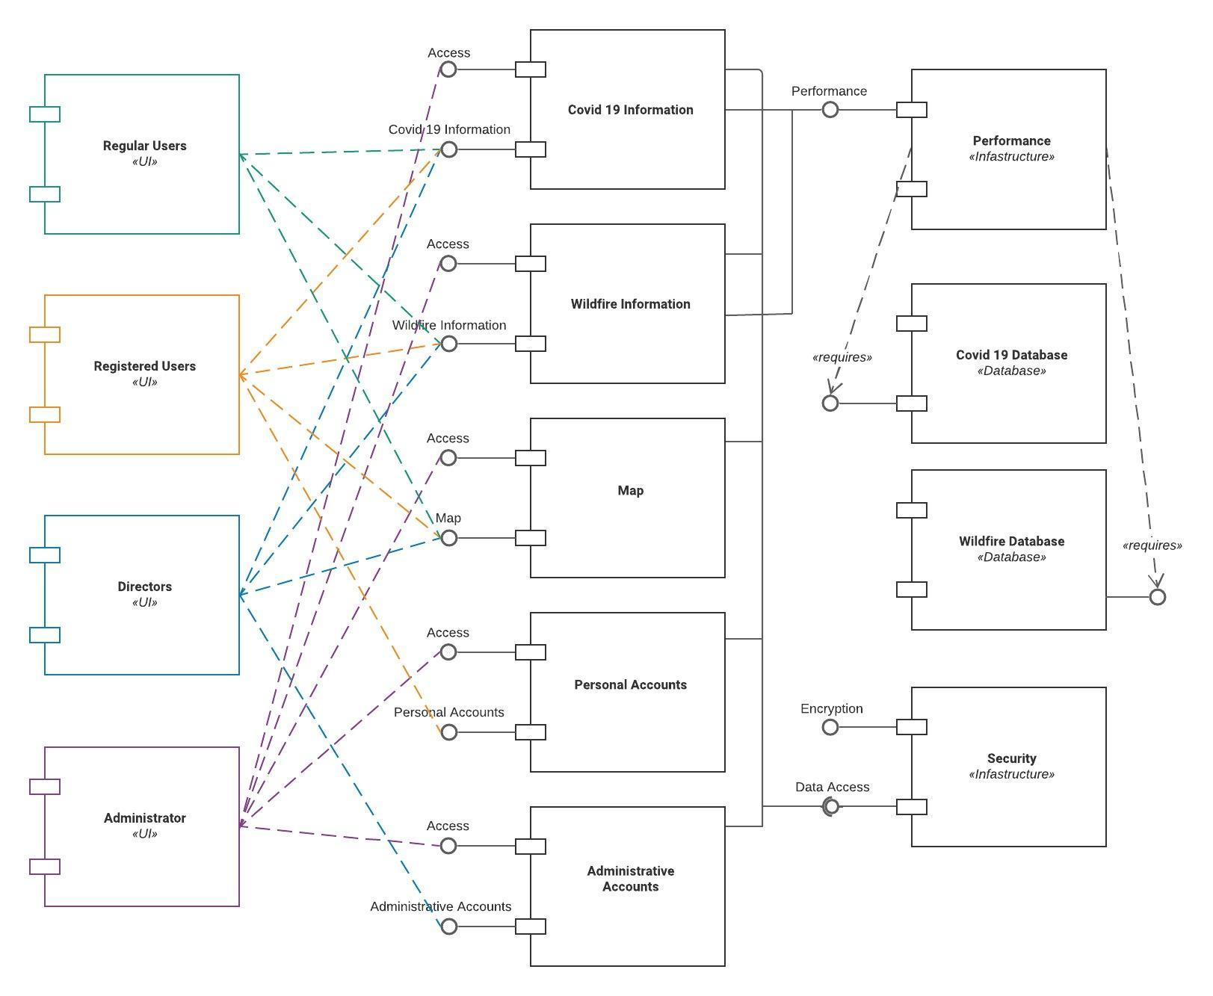

**5 .Identify actual key risks for your project at this time**

Skill Risks (do you have the right skills)

Our team has different ranges in skill levels, high and low. So there is a risk in not understanding the material and resources in time. Having a team with equal levels of skills is generally easier to manage than a team with differing levels of skills because there is a demand to catch up in areas that they are lacking. Since there is a gap in knowledge it can be a challenge to communicate certain ideas to others who don’t have the background and aren’t familiar in the subject. One way to address this issue is to focus on what needs to be done in a project, which is to divide tasks appropriately and direct them to areas that they are able to manage or have a hand in something they are most familiar with within their level. And when someone doesn’t understand something they should inform their team that they are stuck, then the team can plan around that issue and discuss together what can be done to assist them.

Milestone Comprehension Risks

Another key risk in our project that is common in our team is the interpretation of the milestone requirements/instructions. People take in information differently, some things stick out more/less to others. This ends up causing misunderstandings or confusion in our discussions on where to move forward on an issue or when proceeding with a plan. We end up having to send emails to our CTO for more clarifications because no one can agree or is sure if it’s supposed to be done this way or that way. Ultimately, the one thing we do agree on is the CTO is our be-all and end-all on whatever we are doing. Usually we send it as soon as we are aware of the problem.

Time/Scheduling Risks

A key risk in our project at this time, is scheduling/time risk that also ties in with technical and teamwork risks. We have varying amounts of time scattered in different hours of the day and sometimes things happen where we are unable to do/attend the task that was scheduled. That can hold the project back if it is not dealt with as soon as possible. The only solution is to address it early and give the team a heads up so they can redirect to a different arrangement/plan. We can minimize the risk by doing things with an ample amount of time left, giving us more chances to understand and execute our goals, and a better possibility to finish on time. To put it another way, waiting till the last minute to do something or withholding concerns can generate small inconveniences that grow and end up causing a domino/snowballing effect affecting every other risk we are facing.

Technical Risks

Additionally, we have encountered technical difficulties at this time where one of our teammates accidentally damaged their PC so it either has to be repaired, or they have to buy a new one which is unfortunate. This made them unable to participate in one of our scheduled meetings because they were waiting for it to be repaired. Luckily they do have another backup laptop.We can’t 100% avoid incidents like these, we can only inform what we can as soon as possible and try to minimize the effects.

**6. Project Management**

In Milestone 2, we have decided to at least meet on Discord at least every Friday to discuss and work on Milestone 2. We felt that the Friday meetings were not only productive but also efficient when it comes to working and finishing on the Milestones. We are currently having Fridays as our day of our general meeting as well as coordinating with other team members on what other days they would like to meet at. Other than Friday, our team meets on Mondays and Tuesday evenings to iron out any miscommunications and to check up on each other’s progress. When starting out on a new milestone we usually assign tasks to do for the milestone requirements during the breakout room or discuss it on our usual Friday meetups. In addition, for our task management, we have decided to use Trello as well as use Discord as well for planning out on who is responsible and who is in charge of what specific portions of the assignment.